Your Name
Your Street Address
Your City, ST ZIP
Name of Reporter
Street Address
City, ST ZIP
2/14/2000
Account Number
RE: Confirmation letter.
Dear Name of Reporter:
I would like to confirm our telephone conversation on (date) at (time) with (name of person spoken to at company) as to the settlement of above stated account.
As discussed, I will pay your company the amount of $ as payment in full for the settlement of this account. Upon receipt of the above payment, your company has agreed to change the entry on my credit file to "Paid As Agreed" In addition, any negative credit information concerning my account, such as "past due" or "charge off" should be deleted from my report.
If you agree to these stated terms and conditions, please acknowledge with your signature and return a copy to me.
Upon receipt of this signed acknowledgment, I will immediately mail you certified funds in the amount stated above.
Name of company

Signature of company officer , Title , date __/__ /___
Printed name of company officer

Sincerely,
Your signature
Your Name
Address
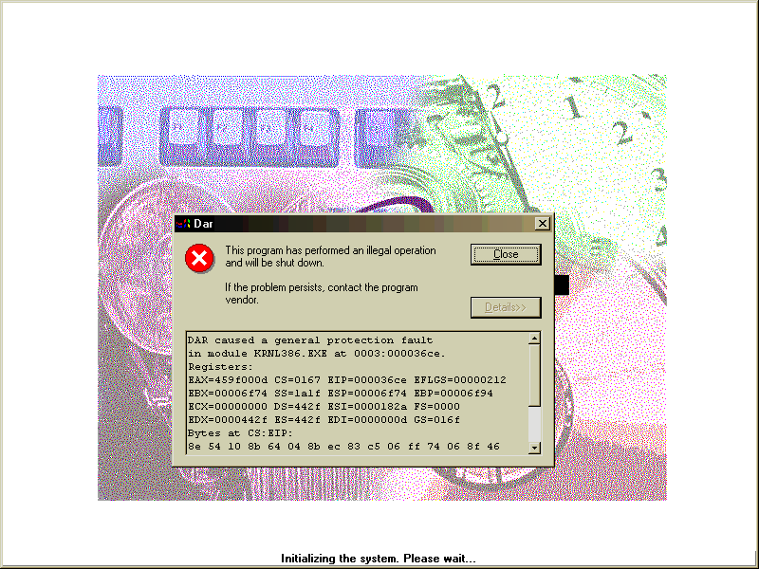
social security number

