Your Name
Your Street Address
Your City, ST ZIP
Credit Bureau
Street Address
City, ST ZIP
2/14/2000

Re: Request For Addition of Credit Information

To whom it may concern:

Please include in my credit report the additional information attached.

According to the Fair Credit Reporting Act of 1996, I am permitted to add relevant credit history to my credit report. This will more fairly reflect my consumer and payment history. Therefore, I request that you add the enclosed payment history to my credit files. Contact information for the creditor is enclosed, should you want to verify the accuracy of the information supplied or require additional information.

Please inform me within 30 days that the additional credit information has been included by sending my updated credit report to my address above.

According to the Fair Credit Reporting Act of 1996, "A consumer's credit report should reflect completeness and accuracy within a reasonable time after notification by the consumer."

Sincerely,

Your signature

Your Name

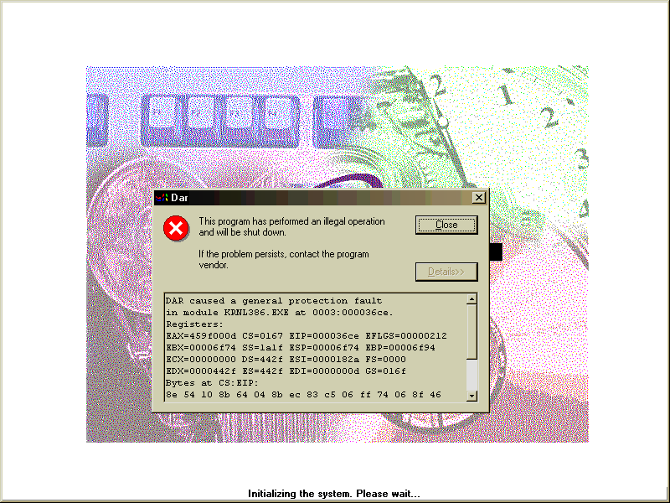
Social Security Number

