Your Name
Your Street Address
Your City, ST ZIP
Credit Bureau
Their Street Address
City, ST ZIP
3/20/2000
RE: Dispute Letter of 2/14/2000
Dear Credit Bureau,
This letter is formal notice that you have failed to respond in a timely manner to my dispute letter of 2/14/2000, deposited by registered mail with the Post Office on that date.
As you are well aware, federal law requires you to respond within 30 days, yet you have failed to respond. Failure to comply with federal regulations by credit reporting agencies is investigated by the Federal Trade Commission. I am maintaining a carefully documented record of my communications with you on this matter, for the purpose of filing a complaint with the FTC should you continue in your non-compliance.
Be aware that I am making a final goodwill attempt to have you clear up this matter. You have 15 days to cure.
For your benefit, and as a gesture of my goodwill, I will restate my dispute. Attached is a copy of the original letter and registered mail receipt. The following information needs to be verified and removed from my report as soon as possible:
CREDITOR’S NAME, acct. 12334567-ABC
The listed item is completely inaccurate and is a very serious error in reporting. Please delete this misleading information, and supply a corrected credit profile to all creditors who have received a copy within the last 6 months, or the last 2 years for employment purposes.
Additionally, please provide me with the name, address, and telephone number of each credit grantor or other subscriber.
Under federal law, you had 30 days to complete your reinvestigation, yet you have failed to respond. Do not delay further.
Be advised that the description of the procedure used to determine the accuracy and completeness of the information is requested to be provided to me within 15 days of the completion of your reinvestigation.
Sincerely,
Your signature
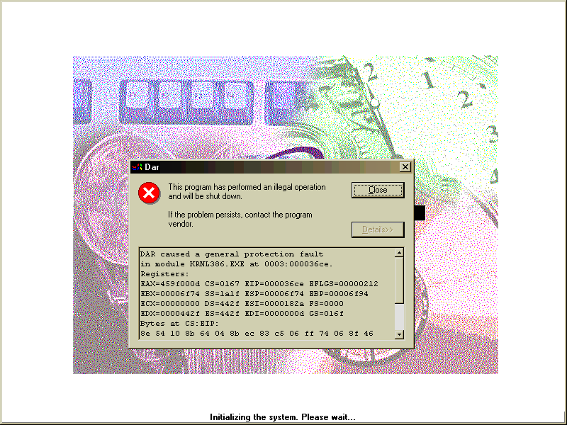
Your Name
SSN# 123-45-6789

