Your Name
Your Street Address
Your City, ST ZIP
Credit Bureau
Their Street Address
City, ST ZIP
4/28/2000
RE: Dispute Letter of 2/14/2000, Follow-up Letter of 3/20/2000
NOTICE OF INTENT TO FILE COMPLAINT
Credit Bureau,
This letter shall serve as formal Notice of my Intent to file a Complaint with the Federal Trade Commission, due to your blatant disregard of the law.
As evidenced by the attached copies of letters and mailing receipts, you have received by registered mail both a dispute letter, dated 2/14/2000, as well as a follow-up letter, dated 3/20/2000. As of this moment, you have disregarded your duty mandated under the law. Your inaction in this matter is inexcusable, and your blatant disregard for the law is contemptible. Rest assured, I will hold you to account for your willful disregard of your lawful obligations.
For the record, the following information is being erroneously included on my credit report, as I have advised you on two separate occasions, more than __ days and again __ days ago:

CREDITOR’S NAME, acct. 12334567-ABC

If you do not immediately remove this inaccurate and incomplete information, I will file a formal complaint with the FTC. Furthermore, I intend to seek redress in civil action, for recovery of damages, costs, and attorneys fees, should you continue in your deliberate obstruction of the law. For this purpose, I am very carefully documenting these events, including the lack of response REQUIRED under law from you.
You are further directed to supply a corrected credit profile to all creditors who have received a copy within the last 6 months, or the last 2 years for employment purposes.
Additionally, please provide me with the name, address, and telephone number of each credit grantor or other subscriber.
Under federal law, you had 30 days to complete your reinvestigation, yet you have failed to respond. Your continued delays are inexcusable.
Be advised that the description of the procedure used to determine the accuracy and completeness of the information is requested to be provided to me within 15 days of the completion of your reinvestigation.
Sincerely,
Your signature
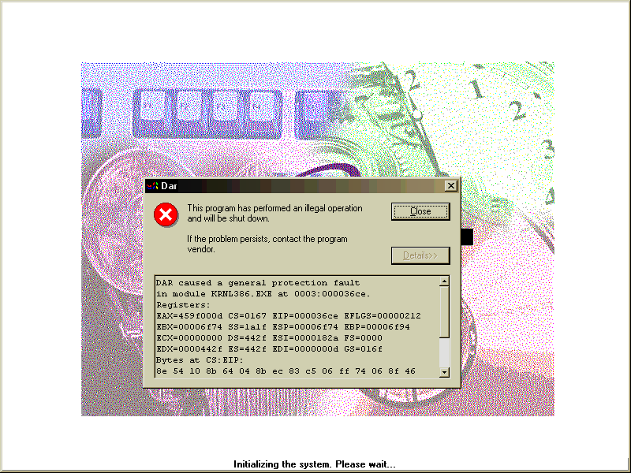
Your Name
SSN# 123-45-6789

