Your Name
Your Street Address
Your City, ST ZIP
Collection Agency Name
Their Street Address
City, ST ZIP
3/15/2000
SECOND NOTICE
This second notice is my response to your unsigned letter dated January 28, 2000, a copy of which is enclosed.
As I have not heard back from you in over 30 days since my notice of dispute dated 2/14/2000, and since you have not supplied the demanded proof of the alleged debt, under the doctrine of estoppels by silence I may presume that no proof of the alleged debt, nor therefore any such debt, in fact exists.
In a good faith effort to resolve the matter amicably, I restate my demand for proof of the debt, specifically the alleged contract or other instrument bearing my signature, as well as proof of your authority in this matter. Absent such proof, you must terminate this collection action, and correct any erroneous reports of this debt as mine.
For the record, I state again: As I have no account with you, nor am I your customer, nor have I ever entered a contract with you, I must ask you to provide the following information:
- Please evidence your authorization under 15 USC 1692(e) and 15 USC 1692(f) in this alleged matter.
- What is your authorization of law for your collection of information?
- What is your authorization of law for your collection of this alleged debt?
- Please evidence your authorization to do business or operate in this state.
- Please evidence proof of the alleged debt, including specifically the alleged contract or other instrument bearing my signature.
You have 20 days from receipt of this notice to respond. Your failure to respond, on point, in writing, hand signed, and in a timely manner, will work as a waiver to your claims in this matter, and will entitle me to presume that you sent your letter in error and this matter is permanently closed. Your continued silence is unacceptable. Either provide the proof or correct the record as required by law.
For the purposes of 15 USC 1692 et seq., this Notice has the same effect as a dispute to the validity of the alleged debt and a dispute to the validity of your claims. This Notice is an attempt to correct your records, and any information received from you will be collected as evidence should further action be necessary. This is a request for information only, and is not a statement, election, or waiver of status.
Your signature
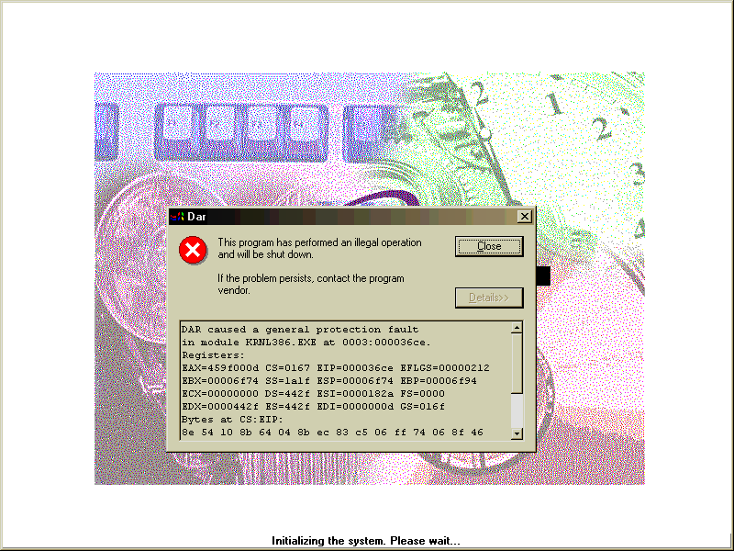
Your Name

