Your Name
Your Street Address
Your City, ST ZIP
Credit Bureau
Their Street Address
City, ST ZIP
4/15/2000
Dear Credit Bureau,
This letter is a formal request for the description of the procedures used to determine the accuracy and completeness of the disputed information, including the business name, address, and telephone number of any furnisher of information contacted in connection with this reinvestigation.
I am disappointed that you have failed to maintain reasonable procedures to assure complete accuracy in the information you publish and insist you comply with the law by providing the requested information within the 15 days allowed.
For your benefit, and as a gesture of my goodwill, I will restate the relevant dispute:
CREDITOR’S NAME, acct. 12334567-ABC
As previously stated, the listed item is inaccurate and a serious error in reporting. Please supply a corrected credit profile to all creditors who have received a copy within the last 6 months, or the last 2 years for employment purposes.
Additionally, please provide the name, address, and telephone number of each credit grantor or other subscriber.
Sincerely,
Your signature
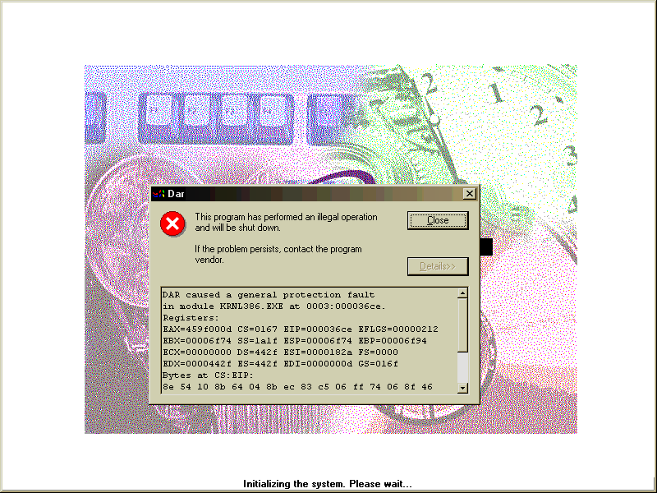
Your Name
SSN# 123-45-6789

